User Stories
- As a user with autism, I would like there to be options to reduce volume
- As a user with autism, I would like there to be options with clear steps that I can read at my own pace
- As a user with autism, I would like there to be a clear consistent layout so that I can navigate easily
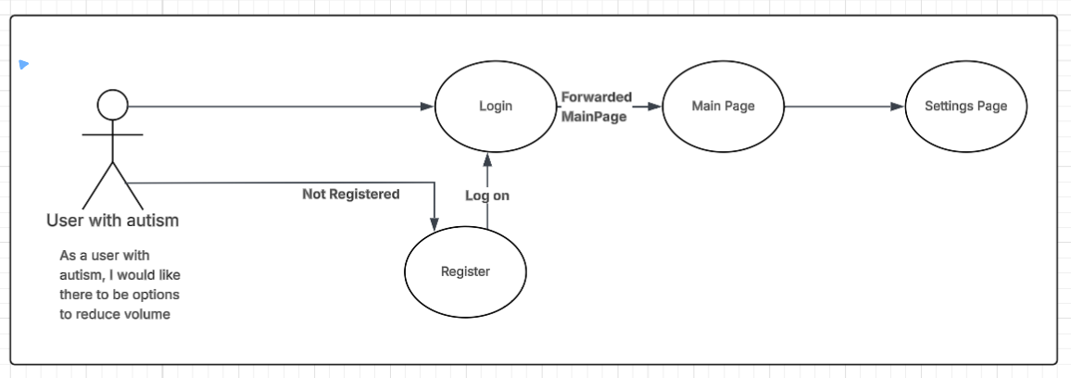
User stories
- As a parent, I would like my children to track their hygiene and establish a routine
- As a parent, I would like for my child to feel calmer when visiting the dentist
- As a parent, I want the experience to remain predictable and simple for my child
